Shayan Taheri --- Full Custom VLSI Design --- Projects 1 and 2 Report

Introduction

In this project, the design of an inverter along with its schematic and layout implementation are studied. The implementation along with functional verification are done using a set of computer aided design tools from the Cadence company. The suite of these tools is called “Front to Back Design Environment” (a.k.a. Virtuoso). Also, the inverter is characterized (i.e. by transistor sizing) at both schematic-level and layout-level in order to achieve symmetrical logical transitions as well as find optimal rise and fall times. Also, the effect of inverter characterizing on its energy consumption is investigated.

Inverter Design, and Implementation at Schematic and Layout Levels

Once the schematic and the layout of inverter are designed on paper, they can be drawn in Cadence. In the first step, a library (Original Library) is created for the original cells (or gates) and another library (Test Library) is created for their test-bench circuits. Meanwhile, a symbol is created for each original cell in order to instantiate it in its corresponding test-bench circuit. Figure 1 and 2 show the original inverter cell content and its test-bench circuit.
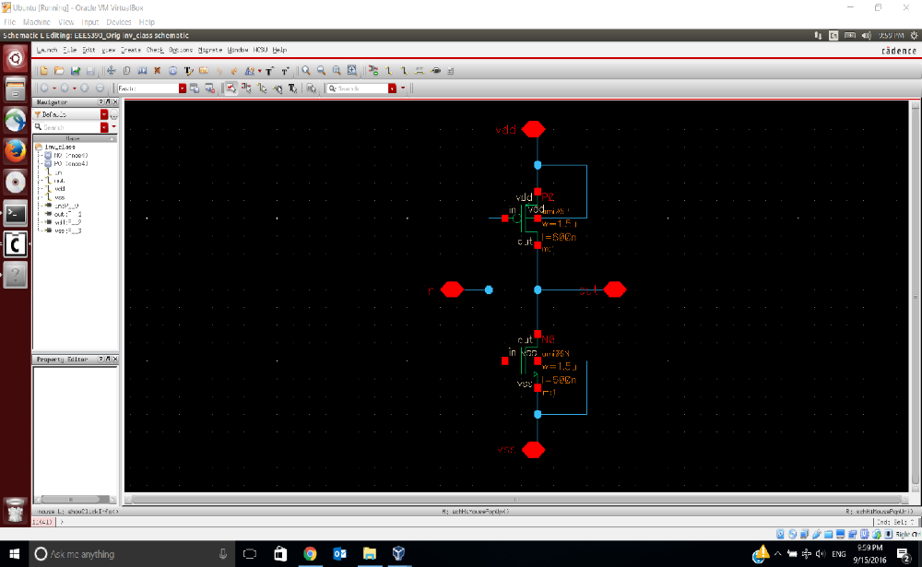
Figure 1: The inverter cell schematic
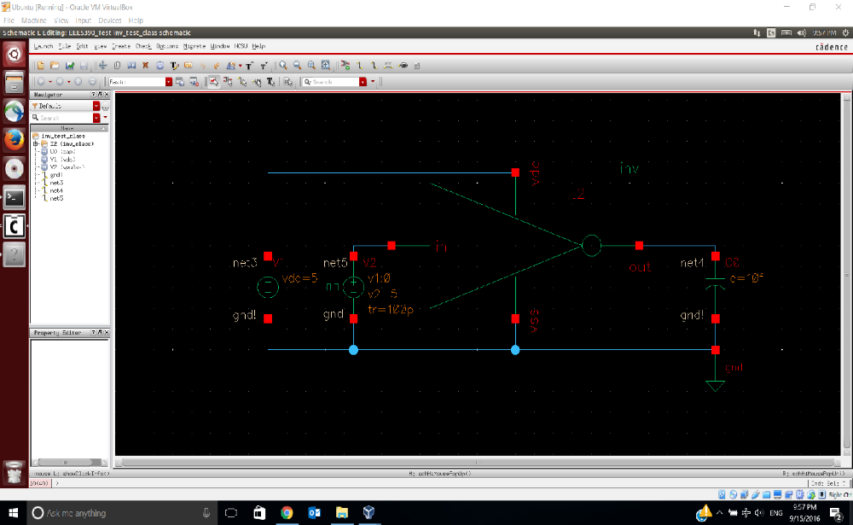
Figure 2: The inverter cell test-bench circuit

In this step, the cell functionality can be verified using Analog Design Environment (ADE) tool. Next, the inverter layout is drawn according to the considered “width” and “length” of the p-type and n-type MOSFETs in the original cell. The drawn layout goes to design rule checking and layout versus schematic verification before its functional simulation. The layout of the original inverter cell is shown in Figure 3.
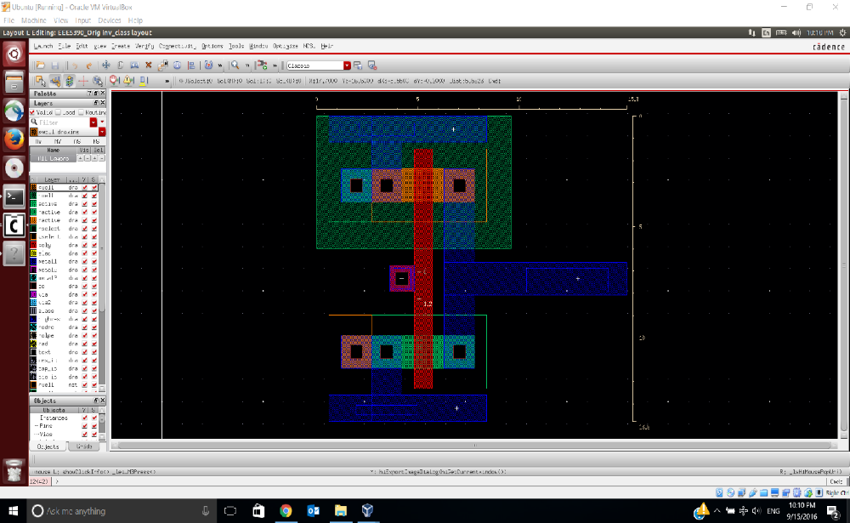
Figure 3: The inverter cell layout
This layout design demonstrates the rise time ($t_{r}$) and fall time ($t_{f}$) of 275.0 (picosecond) and 127.3 (picosecond) respectively, and its area is 211.14 ${μm}^{2}$ (width = 15.3 $μm$, and height = 13.8 $μm$). In order to decrease the rise time and fall time below 100 (picosecond), the NMOS and PMOS transistors should be sized (i.e. adjusting only their widths, and the lengths are kept the same due to the transistor technology defaults). At schematic-level, the task is easier because of: (a) having more number of values to choose, and (b) easy examination of different values by parametric analysis. In this regard, two variables are assigned to the widths of transistors according to Figure 4. Also, the width of the PMOS transistor is considered as twice as the width of the NMOS transistor according to the MOSFET theory.
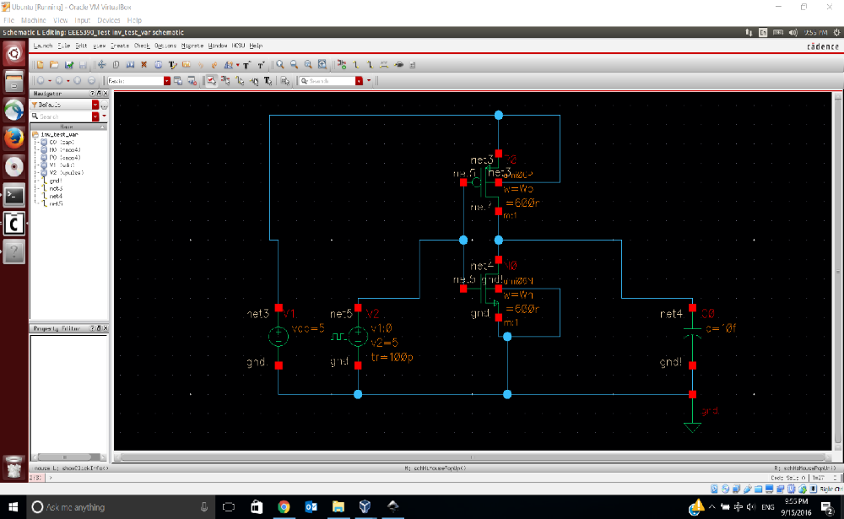
Figure 4: The inverter cell schematic for parametric analysis

After examining various options for the NMOS width, it is found that the optimal value is between 3.9 $μm$ and 4 $μm$. Then, 20 data points in this range (with equal distance between them) are tested. According to the simulation outcome, the optimal NMOS width is 3.957895 ($μm$). The results of this experiment are shown in Table 1 and Figures 5-9.

NMOS Width  ($W_{n}$) | PMOS Width  ($W_{p}$) | Rise Time  ($t_{r}$) | Fall Time  ($t_{f}$) | Delay  ($t_{D}$) | Energy Per Transition  ($E$) | E $×$ $t_{D}$  ($EDP$)
$$3.957895 μm$$ | $$7.91579 μm$$ | $$95.92 ps$$ | $$95.91 ps$$ | $$95.915 ps$$ | $$506.4 fj$$ | $$4.857 × {10}^{-23}$$  $j.s$

Table 1: The simulation results of the sized inverter cell at schematic-level

- The delay parameter is assumed to be equal to the average of rise time and fall time.

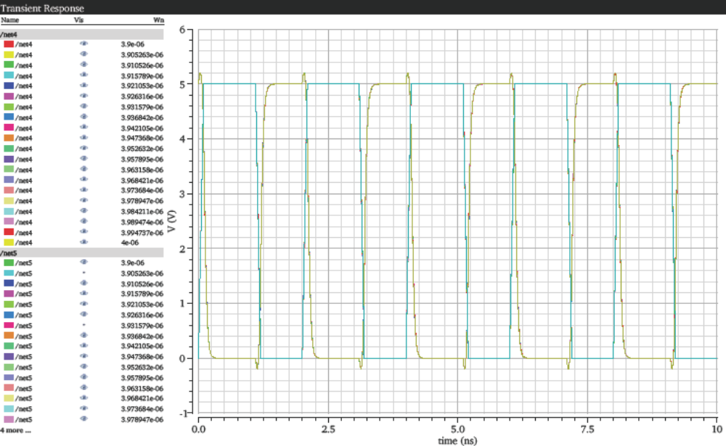
Figure 5: The inverter schematic transient simulation for different transistor widths

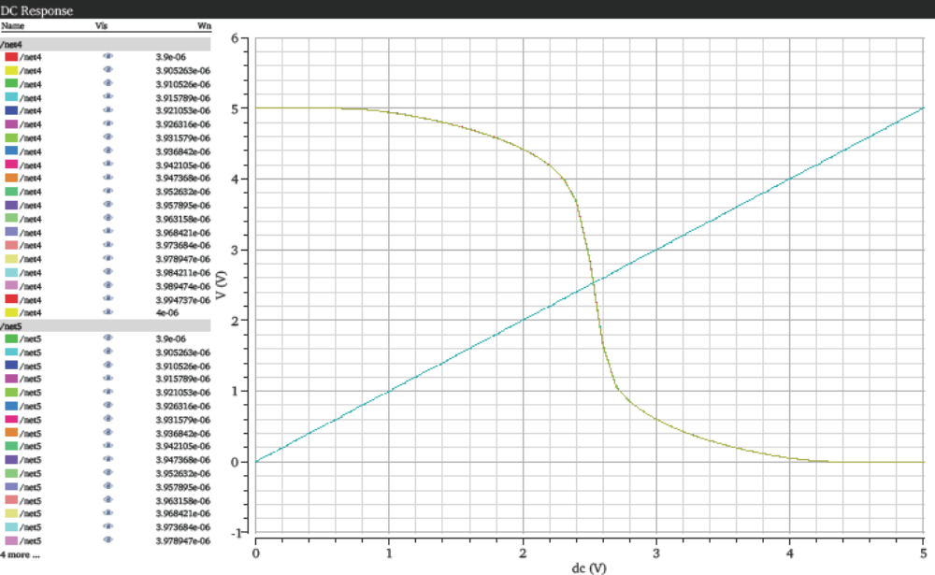
Figure 6: The inverter schematic DC simulation for different transistor widths
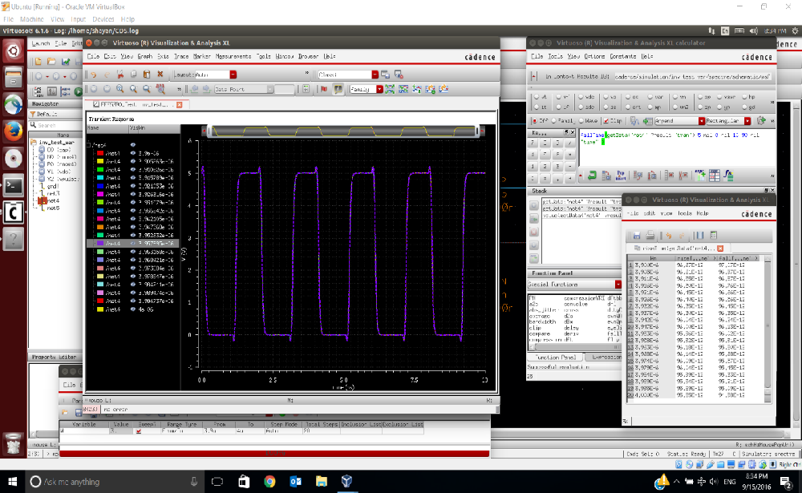
Figure 7: The inverter schematic rise and fall times for different transistor widths

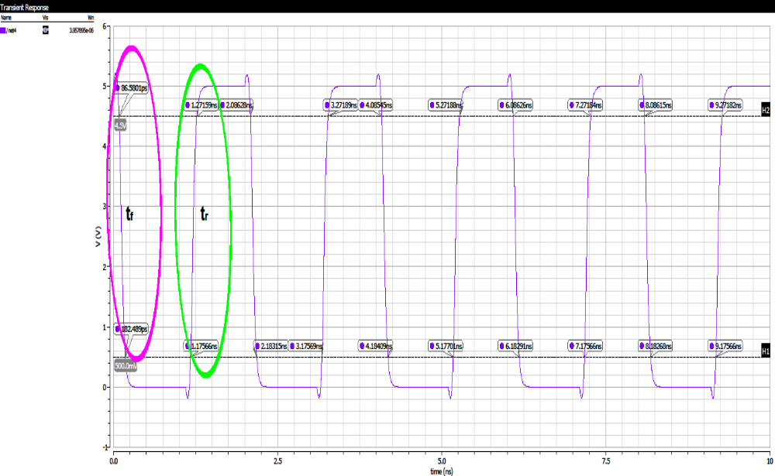
Figure 8: The inverter schematic rise and fall times on the transient waveform
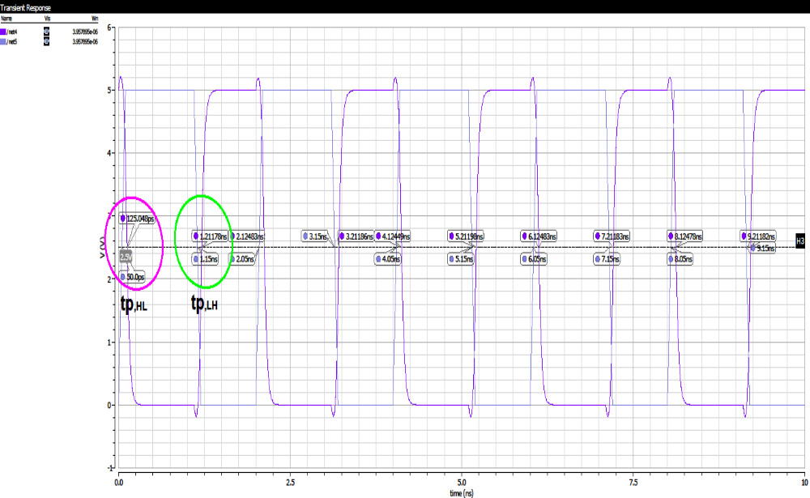
Figure 9: The inverter schematic high-to-low and low-to-high propagation times on the transient waveform

In the last step of this project, the layout of inverter is redrawn for two purposes: (a) considering the PMOS width twice as the NMOS width, and (b) minimizing the layout area based on the MOSIS Scalable CMOS (SCMOS) Design Rules. After completing the inverter layout extraction, it is simulated in order to verify its functionality and calculate its rise time and fall time. Figures 10 and 11 display the inverter layout before and after the extraction.
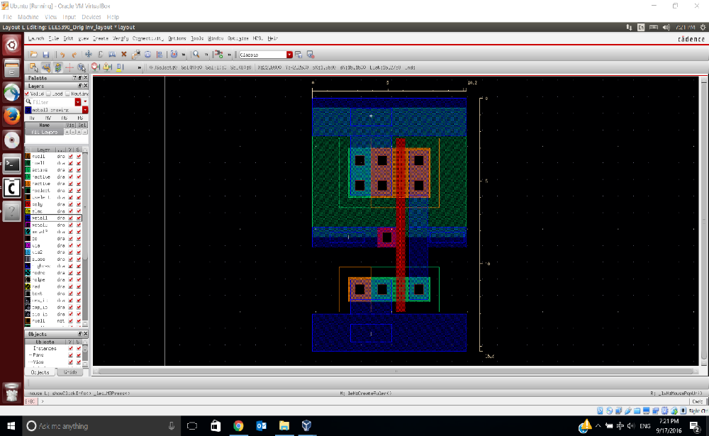
Figure 10: The inverter cell layout with the PMOS width twice as the NMOS width
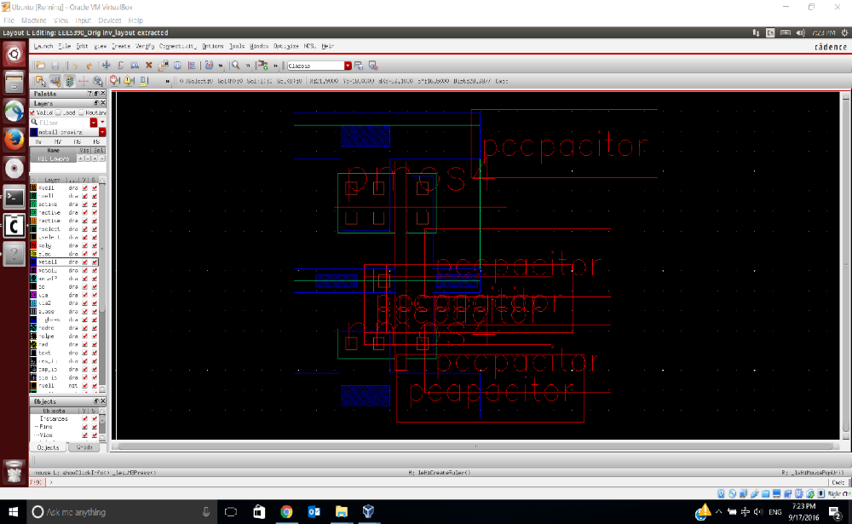
Figure 11: The inverter cell extracted layout with the PMOS width twice as the NMOS width

As it can be seen from the figures, the layout area is 156.06 ${μm}^{2}$ (width = 10.2 $μm$, and height = 15.3 $μm$). The transient simulation of the extracted layout is shown in Figure 12. This layout provides the rise time ($t_{r}$) and fall time ($t_{f}$) of 80.24 (picosecond) and 98.42 (picosecond) respectively that are both lower than 100 (picosecond).
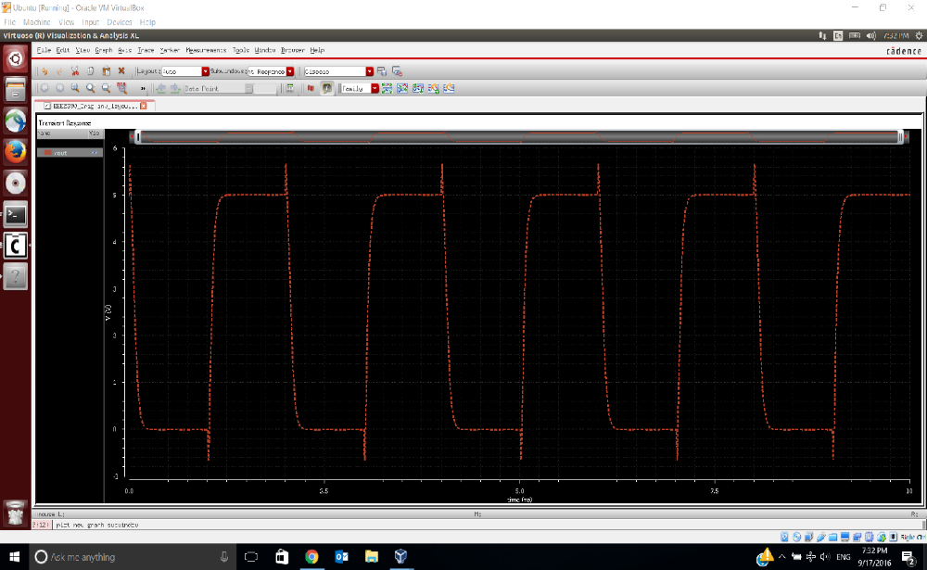
Figure 12: The inverter cell extracted layout transient simulation
Conclusion

This project consists of two phases: (a) getting familiar with the Cadence tool-suite to be able to design and implement very large integrated circuit cells at the schematic and the layout levels, (b) characterizing an inverter at the schematic and the layout levels in order to improve its rise and fall time along with energy consumption. According to the simulation results, doubling the PMOS width (i.e. used in pull-up network) in compare to the NMOS width (i.e. used in pull-down network) can decrease the transition delay, which is in accordance with the MOSFET theory.

